About Phil…
I still occasionally lead highly interactive keynotes and workshops on assessment, feedback, learning and teaching in higher education. I also publish widely on such things, and details of my work can be found on my website http://phil-race.co.uk. My passion is about ‘making learning happen’, in an approachable way, without recourse to jargon, acronyms or elitism.
I started as a scientist, but gradually became an educational developer. I failed to retire from the University of Glamorgan in 1995, and again from Leeds Metropolitan University in 2009, and am Emeritus Professor, and also Visiting Professor at the University of Plymouth, and University Campus Suffolk, I continue to travel the country (and world sometimes) running workshops for teaching staff. My work was recognised in 2007 by the Higher Education Academy awarding me a National Teaching Fellowship. In 2012 I gained the status of Principal Fellow of the HEA, and an Honorary Doctorate in Education from Plymouth University.

Home is Newcastle upon Tyne, UK. My wife is Professor Sally Brown, now retired after serving as Pro-Vice-Chancellor (Academic) at Leeds Metropolitan University for several years – see her website at http://sally-brown.net. Beyond education, my passion is classical music, and I am an accomplished performer on the CD player and iPod.

I am known for using lots of post-its in various colours for brainstorming and prioritisation group exercises at workshops, I am also known for bringing humour into presentations and keynotes – but always with the purpose of highlighting important points here and there.
My best known books are ‘Making Learning Happen: 3rd edition’ (Sage, 2014), and ‘The Lecturer’s Toolkit: 4th edition’ (Routledge, 2015).

In this booklet, I’ve trimmed down the range of the half-day workshops I offer to include just the most popular ones, but am always happy to design custom-made sessions based on clients’ needs and wishes.
Half-day programmes: e.g. 0930-1200
- How students really learn – addressing seven factors underpinning successful learning
- Smarter feedback – and feed-forward
- Towards assessment as learning
- Smarter lectures – getting engagement in large group contexts in the digital age

Indicative Programmes for workshops
The menu of half-day and full-day workshops which follows links to my two main books, which took forward the ‘ripples on a pond’ model of the factors underpinning successful learning which I have been developing over the last two decades.

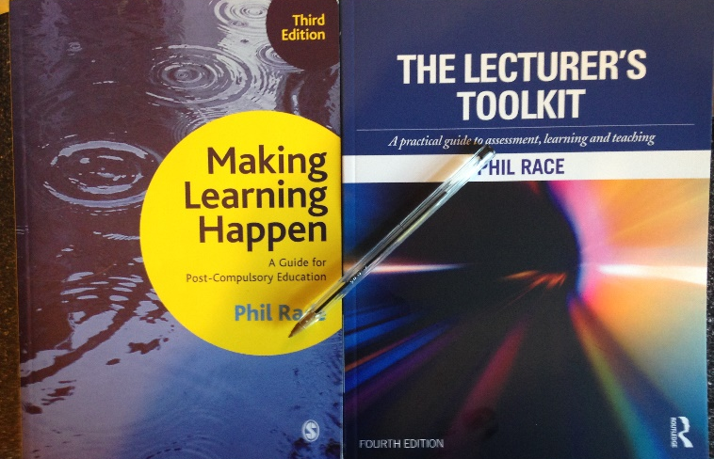

I’m not easy to contact by phone or post!
To contact me please use email, or ring me on my mobile – email me for the number at phil@phil-race.co.uk but don’t worry if I don’t reply for a few days sometimes when I’m ‘on the road’, abroad, or on holiday and out of email contact. The ‘home’ page of this website sometimes explains where I am, and the ‘out of office’ reply on my emails almost always says where I am and when I’ll be back in Newcastle.

What I usually need
Just sometimes I forget to remind my clients what I need at their end to run staff development workshops. I need data projector for PowerPoint (and the odd video clip) but bring my own laptop, so I need a VGA link to your system or direct to the projector. I also usually need a flipchart (mainly for post-it activities), and some post-its please. For large groups, or in rooms with difficult acoustics, I need a microphone – I speak quietly!

1 How students really learn
– addressing seven factors underpinning successful learning
Rationale
This workshop offers a jargon-free exploration of how students really learn, based on my having asked some 200,000 people around the world (and in just about every discipline) a series of straightforward questions about how they learn best – and what goes wrong with their learning. We identify the main factors which underpin successful learning, and the way that these factors interact with each other (like ‘ripples on a pond’), and how it is unwise to think of them in terms of learning cycles.

Intended learning outcomes
After participating in this workshop, you will be better able to:
- Identify seven factors which underpin successful learning.
- Fine-tune teaching to address these factors.
- Move away from old-hat views about learning styles and learning cycles!

Workshop Outline Programme
0930 Coffee, informal introductions.
1000 Introduction, participants' expectations.
1020 Exercise: ‘making student learning happen would be much better for me if only…’ and discussion of matters arising.
1100 Coffee.
1120 Interactive exploration of answers to six fundamental questions about learning successfully.
1200 ‘Ripples on a pond’ way of addressing how students learn naturally.
1230 Close of workshop.

Reference materials
Race. P. (2014) Making learning happen, 3rd edition London: Sage.
Race, P. (2015) The Lecturer’s Toolkit: 4th edition, London: Routledge.
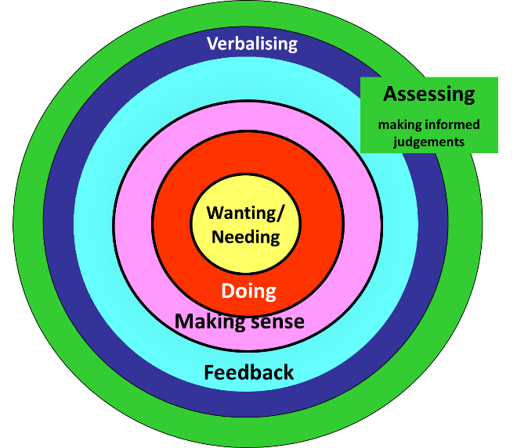

2 Smarter feedback
- a half-day workshop on giving better feedback to more students in less time!

Rationale
The UK National Student Survey used since 2005 has shown that one of the areas causing most dissatisfactory is students’ experience of feedback. What’s wrong with formative feedback? It can be too late. It can demotivate students instead of motivating them. It can take too much of our time, and yet students may take little notice of it. Too often, it can be feedback only, rather than also being feed-forward.
This workshop explores how we can give more and better feedback to more students – in less time! Included are suggestions about how students can be given feedback within 24 hours. We’ll explore a range of feedback methods, so that you can make your feedback more effective, and less time-consuming, We will explore the pros and cons of paper-based, word-processed, and electronically delivered feedback, in terms of the learning payoff which students derive from feedback, and the efficiency for us in providing it for them.

Intended learning outcomes
After participating in this workshop, you should be able to:
- Give better feedback to more students in less time.
- Choose feedback methods where the student learning payoff is high, and stop wasting your time on feedback that isn’t used.
- Prevent marks from detracting students from useful feedback.
- Use student self-assessment as a way of giving them really useful feedback.

Workshop outline programme
0915 Coffee, informal introductions.
0930 What goes wrong with student feedback? Exercise: “giving feedback to my students would be much better for me if only I…”
0945 What the gurus tell us about feedback
1000 Exercise on effectiveness and efficiency of a wide range of feedback processes.
1100 Coffee break.
1120 Feedback without marks, and ways of using student self-assessment to start rich feedback dialogues.
1230 Close of workshop.

Reference materials
Race. P. (2014) Making learning happen, 3rd edition London: Sage.
Race, P. (2015) The Lecturer’s Toolkit: 4th edition, London: Routledge.

3 Towards assessment as learning
- a half-day workshop on making assessment more valid, reliable, transparent, authentic, inclusive – and manageable!

Rationale
This workshops starts from the premise that ‘assessment is broken’ in higher education at present. We will explore what we can do to make assessment more fit-for-purpose, and help it to be a better driver for students’ learning. We will look at the pros and cons of some of the most often-used processes and instruments in our traditional approaches to assessment, and explore what else we can do to improve assessment. We will also look at how we can use formative assessment to open up feedback dialogues with students to deepen their learning and help them to make the most of our feedback to them. We will explore how best we can make assessment better for students by involving them in self- and peer-assessment.

Intended learning outcomes: After participating in this workshop, you will be better able to:
- Explore how assessment has become ‘broken’ in higher education at present.
- Review ‘what the gurus tell us’ about assessment and feedback in higher education.
- Interrogate a particular assessment element of your own, regarding how well it links to how students really learn, and to validity, reliability, transparency, authenticity, and manageability.
- Use student self-assessment to initiate student-tutor dialogues, and make our feedback more useful to students;

Workshop Outline Programme
0915 Coffee and informal introductions.
0930 Introductory exercise: ‘Assessment would be much better for me if only I…’
1000 ‘What the gurus tell us’ about assessment and feedback in higher education.
1045 Coffee break.
1100 Towards assessment as learning: interrogating one of your own assessment elements against validity, reliability, transparency and so on.
1200 Involving students in their own assessment.
1230 Close of workshop.

Reference material
Race. P. (2014) Making learning happen, 3rd edition London: Sage.
Race, P. (2015) The Lecturer’s Toolkit: 4th edition, London: Routledge.

4 Smarter lectures
- a half-day workshop on making learning happen in large-group settings

Rationale
This workshop is about making learning happen in large-group contexts, by addressing how students learn in lectures, and making students participative rather than passive. It is well established that just sitting in traditional lectures is not the best way for students to achieve high learning payoff. We’ll explore ways to maximise students’ learning then and there, rather than merely hope that they will go away and learn later from our handouts and their notes. We will also look at how to address the physical constraints of the learning environment in lecture theatres or large classrooms, We will analyse some of the most prevalent problems we have when working with large groups, and seek creative solutions to the most common of these problems.

Intended learning outcomes: After participating in this workshop, you will be better able to:
- Address how students really learn in your large-group teaching.
- Make large group contexts an active learning experience for your students.
- Creatively address some of the problems we often find in large-group teaching contexts.
- Analyse which of your teaching actions maximise the learning payoff for your students.

Workshop Outline Programme
0915 Coffee and informal introductions.
0930 Introductory exercise: ‘large-group teaching would be much better for me if only I ...’.
0945 Analysing what students do in large-group contexts, and addressing seven factors which underpin successful learning in large groups.
1100 Coffee break.
1120 What can we do in large-group contexts? Sharing experience of our best (and worst) teachers, and building on this.
1200 ‘What can I do when…?’: creative problem solving exercise.
1230 Close of workshop.

Reference material
Race. P. (2014) Making learning happen, 3rd edition London: Sage.
Race, P. (2015) The Lecturer’s Toolkit: 4th edition, London: Routledge.

