Returning full circle (Phil Race)
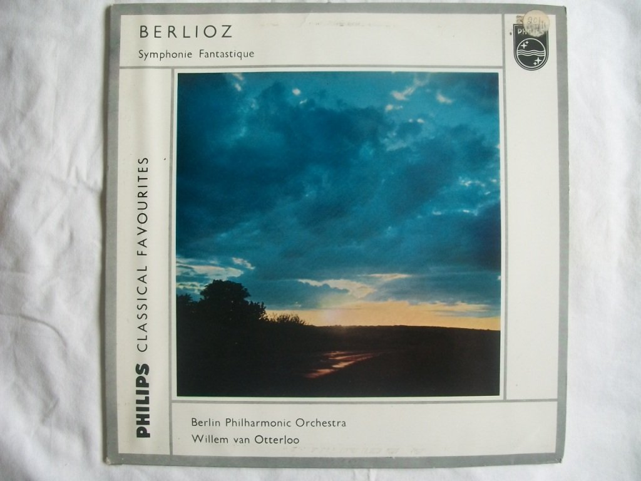
One of the early LPs I bought as a teenager was Willem Van Otterloo conducting the Berlin Philharmonic in Berlioz ‘Symphonie Fantastique’. (I already had Otterloo’s reading of Beethoven’s ‘Pastoral’ symphony, with the Vienna SO, with great sleeve notes written long ago by Berlioz, so there was a thread).
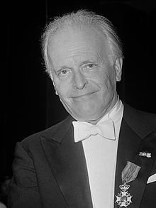
I fell in love with the ‘Fantastique’ very quickly, and it would still be one of my ‘Desert Island’ choices decades later. After hearing and buying over the years dozens of other interpretations, despite Otterloo missing out repeats (as was normal in those days), I kept returning to the terrific playing of the Berlin PO for him, and in particular the very ending of the ‘March to the Scaffold’ where they did the last blast ‘staccato’, like the executioner’s chop! No other conductor has achieved that. Also, in the middle movement, the BPO’s timpanists realise the most stunningly natural-sounding thunder in the storm scene. Otterloo later recorded the ‘Fantastique’ with his Hague Orchestra in stereo – but for me that did not match the sound he drew from the Berliners way back in 1951.
My treasured and well-worn LP, which remains in my loft, had its fair share of clicks and crackles, not least as the 2nd side was long and the groove fine. Some years ago I got a turntable to transfer this and a dozen other favourites to digital sound, but the results were not good. Nevertheless, my transfer has remained on one of my iPods and still gives pleasure. It was in one of my favourite home-based relaxing positions, sitting with the iPod shuffling through my sound system that the slow movement of the ‘Fantastique’ came on, and I happened to ‘Shazam’ it, guessing that its elderly and much-processed sound would not be recognised. Not, so – soon I was purchasing and downloading a far better reproduction on i-tunes.
Who will ever know how musical history might have been different if those appointing a successor to the Amsterdam Concertgebouw’s Eduard van Beinum after his untimely death had not decided to ‘skip a generation’, overlooking Otterloo, appointing a young, inexperienced Bernard Haitink to the post, probably causing Otterloo to move to Melbourne then Sydney for the rest of his life. But then, my musical enjoyment is now graced with a great deal of Haitink’s work with the Concertgebouw Orchestra, not least interpreting Mahler, Shostakovich and Debussy – but no Berlioz that I’m aware of.

