Phil Race: jar for ANTF16
I can’t include a photo of the jar itself, as that has already been re-used, and is full of home-made jam Sally made from last-year’s gooseberries from our freezer. However, the three objects are still with me as always. I’ll say here a little about each.
A small pad of post-its
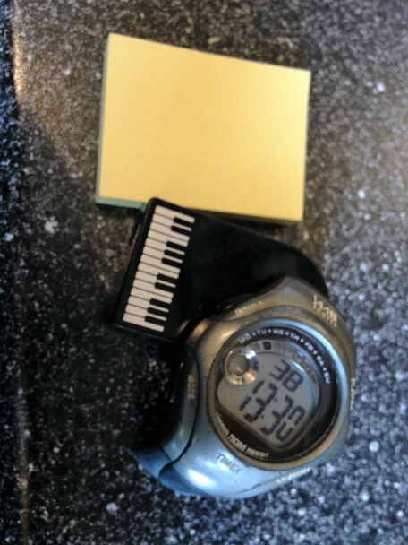
Those who know me will know that I’m rarely without post-its. For years – since long before they were endemic – I’ve been using these for thousands of purposes, including finding out in workshops and keynotes what audience-members think about things. I often use the starter ‘teaching would be much better for me if only I….’ and then ask people to jot down an immediate thought. I then usually ask people to swap the post-its randomly, and get volunteers to read out what’s on the one they now have, with passion and drama. I did this in my workshop at ANTF16, and transcribed the entries to the slides I put on my website for the event.
An old timepiece
I’ve always been fussy about time. I pride myself on never being late, and particularly in finishing any workshop or keynote bang on time, except when finishing a little early. My researches with students have shown beyond doubt that my finishing a little early has never proved to be the worst thing that has happened to them that week. I almost always display a small clock on the screen over any slides I’m using so everyone knows the time, particularly me. Sometimes I lose watches, or the wristband wears out, or the battery runs out, and then I’m flummoxed. For such occasions I usually carry around an old working watch, minus its broken strap, for emergency use – or indeed to lend to people who find themselves temporarily disadvantaged.
A musical keyboard
Music is my main life, and I do everything else to support my music habit. The little ‘keyboard’ in my travel bag is in fact a pencil sharpener, but is enough to remind me of music. I don’t actually like pencils much, as during boring lectures one can’t take them to bits, or ends up eating them. I have a much bigger keyboard at home, but my fingers wont operate it to the satisfaction of my ears, so I usually enjoy listening to other people’s rendition of music, and indeed when it is orchestral music assist the process by conducting. My stepson once walked in on me helping Barbirolli doing Elgar splendidly, and bought me a baton, but this is slightly too big to carry around all the time – and I particularly admire conductors who don’t use sticks. I’ve always preferred carrots to sticks in my approach to teaching and learning, but conducting with a carrot might make people believe I’m even madder than I am.
Footnote: I really enjoyed the creativity and imagination that NTFs put into designing their jars. Great idea!

