Digest of Questions and Responses on the #LTHEchat: 19th October 2016
Phil Race
Below is my attempt to go through the ideas everyone put in as answers to my six questions in the busy Tweetchat we shared last Wednesday evening. It’s actually quite hard to keep Twitter ‘still’ on the screen while copying and pasting bits from it, and many times I lost track of where I was and had to go back to the beginning and start again! This means I may well have pasted some of the same comments twice – and more important – missed out other really good ones. Do let me know. I loved @simonrae ‘s graphic, and thank Simon for letting me paste it into this Digest.
‘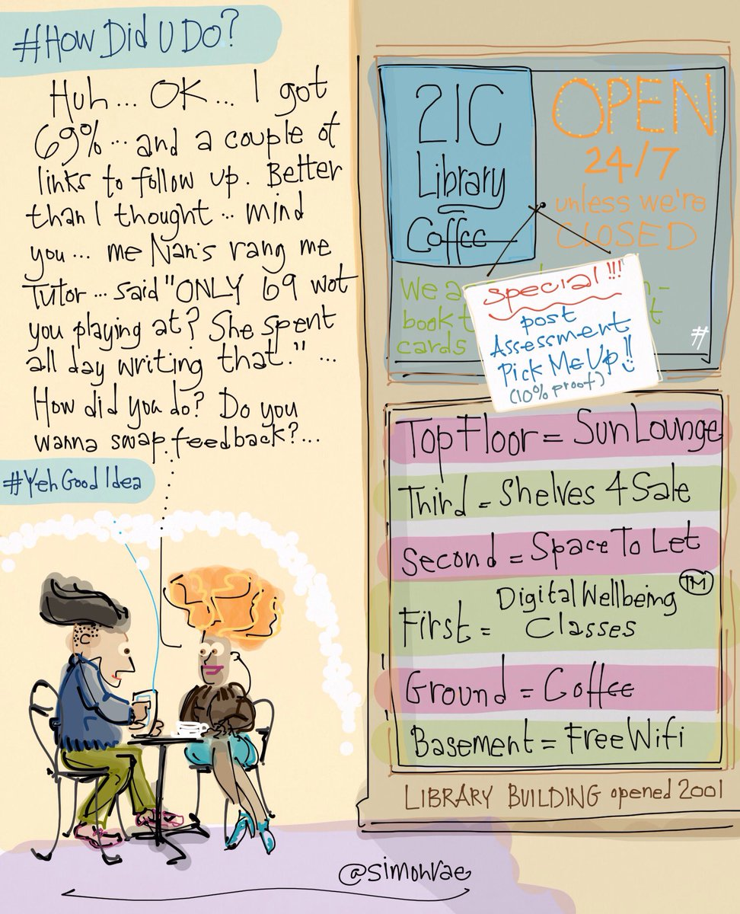

- What was the single most important feedback you ever gained?
- "You *can* do this, just stop trying to please everyone else and do yourself proud."
- "Jazz it up a bit" Feedback to me as a new lecturer in stats, from a student. Led to major reflections on teaching & feedback
- Most important feedback I ever received was from myself, that considered reflective feedback from myself was the most important
- “You're really good at maths for a chemist"
- when I was very new to training ... if you say you'll give 5 minutes to complete a task, don't guess - time it.
- "You're very loud aren't you!"
- You didn't answer the assignment question - you answered what you thought it said instead
- Best feedback I've received was to be myself, but the best version of myself that I could be.
- Read your work out loud to help with spotting grammatical errors
- Last year on EdD was told to let my own voice through more, have confidence that I had ideas worth sharing
- “when you ask questions I don’t always know what you mean. Can you be clearer, please?” Sadly, this was very recently…
- ‘you make a difference in my life'
- Well done Simon, that's good. What's next?
- Feedback that highlighted how little effort I had put in - it made me rethink what I was doing as a student
- ‘To just write and not worry so much - tidy it up afterwards'
- Was once told I made a good job of not blocking the flipchart when in reality I was trying to hide behind it
- It’s all about the learning. No point doing crazy activities or fancy technology if there’s no learning.
- 'lighten up' from a peer observation many years ago
- 'try it a little differently, one last time, before you decide to give up'
- 'don't let the perfect be the enemy of the good'
- Treat it as a learning experience....
- stop waving my arms around when presenting…
- don't be afraid to use your own voice
- 'take more care, don't rush' in primary school. Took me 20 years to enact (I am so not a perfectionist!)
- dialogue can be achieved orally, but also using Twitter, and feedback by students on our feedback, and vice versa
- Agree feedback in situ FTF as conversation dare I say Socratic dialogue or within 24 hrs as Phil fed forward in our homework

- What was the single most damaging feedback you ever had to weather?
- I got some student evaluation feedback that really stung ... wasn't that long ago either! .
- I recall - "could do better" - what's that all about?
- ear Master: "Cross, you'll make nothing of yourself" strangely wasn't damaging feedback. He was spot on back then.
- ''weak'" for art on successive school reports. (Showed sustainability though?)
- 'don't bother getting up on Monday morning' after a failed assignment by a maths teacher at secondary school
- missing out on an A as I read the question slightly wrong
- at age 13 the whole class failed maths exam...to this day I wonder if it was a deliberate teaching strategy!
- A big red cross through something I'd put some effort into, devastating
- "Prof Lancaster relies too much on our understanding."
- during a driving lesson being asked "what do you think you're doing"...um driving?! Not overly helpful!
- Being told, in nicest possible way, by a group of students, that I wasn't giving them what they needed.. and they were right.
- meaningless scribble followed by a low mark - impossible to understand or act upon
- When people focus only on the negative and crush people. “This is crap” is unhelpful on all levels
- Any feedback which wasn’t particularly personal or didn’t give advice on how to improve. Generic school reports come to mind
- "Prof Lancaster should stop getting us do something and get on with providing answers to potential exam questions."
- recently had dreadful feedback from a tutor on my p/t degree course, if I'd have been 18 i'd have walked
- I wear my feedback like scars. Some of the wounds still fester.
- Being told that I was holding up everyone because I didn't understand maths GCSE lesson
- Having to stand up in class to say I got 0/10 on a mental arithmetic test
- a single line, cut from a larger sheet, stapled to a 5000 word essay. I don't remember what it said. Just one line.
- when it makes you feel lost...and is paralysing.
- that I was dribbling a footballer ‘like a ballerina’ by a ‘70s PE teacher (i.e.: Brian Glover, Kes) in front of my mates
- my only consolation was they pulled apart my punctuation and grammar but their feedback was full of typos!
- 'Kerry has ability to do well when she puts her mind to it' Response, Kerry will put her mind to it when she's not bored to death
- Received lots of unhelpful feedback over the years but the genuinely damaging kind has come from my own inner voice.
- A childhood one - being described as a "non-singer" by a teacher (cos my singing judged not up to class choir standard)
- ‘great presentation’ or something like that on a school science lab report. I don’t care about that! Was my conclusion right?!
- severe & not constructive criticism of conference paper I was trying to rework for publication
- on my end of year report for PE aged 14:" Jane does not participate in this subject" (and reader - I never did again!)
- actually worst negative fb was from a boss, who said that as I wasn't perfect it wasn't good enough
- A second marker's feedback was one word - 'Agreed' - when I was hoping for something a little more constructive
- that kind of thing will get worse, as exam prep continues to replace secondary teaching its simple failure to meet expectations
- Simon loves humanity, but must learn to like people. (School report)
- ‘yeah that sounds great’ in response to a funding bid…I wanted you to pick holes in it! The panel aren’t going to be that nice!
- Your essay was let down by ‘imprecise use of language…. There are examples here which make the reader think “What the?”
- ‘Seriously, you CANNOT use these in a professional piece of writing.’
- worst feedback I received was no feedback. My hard work just disappeared into the void...
- Best ever reviewer's feedback in rejection email was "lacks carriage return at end of line 15" (yes this was in the 21st C)
- he worst feedback I eve received on a sweated-over assignment was 'Fine as far as it goes' Grrrh!
- "do it again but better..." was another gem!
- Feedback tools in VLEs and online assignment submission software not always easy to use
- Poor NSS scores have led to more institutional approaches to improve feedback for learning

- To what extent do the present systems and metrics get in the way of making feedback work for learners?
- seems that getting it back in x days is more important than making it useful ... then again, making it useful takes so long!
- Anonymous marking, electronic collection/return, turnaround time for moderation - all important, but depersonalise experience
- General drift towards obsession with the final grade rather than learning as outcome of higher ed
- Good, valuable feedback takes time to do. Time is short..
- Tough!! module assessment leads to course completion...e.g. progression/ retention require mark/grade-feedback not considered?
- Not so much metrics, but time pressures stop necessary conversation happening with learners.
- Much like TEF and teaching our approach to feedback is concerned with nearly everything except the quality and value
- yes, I so agree - battling institutional anxiety and requirements for 'ratified feedback'
- descriptors can be useful but the real quality of fb is in the narrative commentary/audio fb
- summative stakes mean we can't use peer- or self-marking and introduces significant delays.
- Not enough opportunity for dialogue, how do I know if a student has understood the feedback?
- my big worry is the extent to which written feedback is regarded as essential to provide quantitative data for metrics!
- concerned that once students get a mark out of 100 they ignore any discursive feedback on the piece of work
- students only interested in the grade.
- the obsession with anonymous marking
- lack of useful tools to provide helpful reflection on feedback and feed-forward activities
- for me it has to be numbers. Contributing to time taken for feedback, ability to get to know students & personalise, etc.
- Modular systems stop feedback being feed forward, more synoptic assessment would help
- Try posing a question on one slide and an instant later ask them how confident they are in their answer on a fresh slide.
- not sure 'it' does. we can be our worst enemy at times by designing assignments generating poor quality feedback
- not enough time allocated for feedback/forward process
- the presence of a poor question with undefined use of 'feedback' in the NSS
- Too much emphasis on individual assignment, exams & summative assessment. No feedback loops and iteration there
- Tough!! module assessment leads to course completion...e.g. progression/ retention require mark/grade-feedback not considered?
- Much like TEF and teaching our approach to feedback is concerned with nearly everything except the quality and value
- lack on a longitudinal picture of a student progress - systems should be able to provide this
- I would like to see students given opportunities to redraft and resubmit regularly, it's good to act on feedback students have preconceived ideas about what feedback is, often just telling them "this is your feedback" can be v effective
- Lack on a longitudinal picture of a student progress - systems should be able to provide this
- prominence of the low score for FB in NSS leads to knee-jerk "solutions" from management that don’t actually improve things
- By taking up time they probably reduce the teacher's ability to respond to the student as an individual …
- Delays returning feedback because have to get marks moderated first? Inflexible assessment criteria?

- ‘Feedback needs to be a dialogue, not a monologue’: your views?
- completely agree, how else are students supposed to learn from their mistakes? Give them time to do it again
- feedback in many settings beyond an assessment is about DISCUSSING performance so that you learn from the past. In short YES
- Hmm, sounds like a leading question to me... is there a more open way you could have phrased it?
- Is the answer pointing out to students you are giving feedback? "I am now giving you feedback..."
- dialogue with students AND staff
- The worst feedback I ever received on a sweated-over assignment was 'Fine as far as it goes' Grrrh!
- Dialogue is fundamental to effective feedback.
- dialogue can be achieved orally, but also using Twitter, and feedback by students on our feedback, and vice versa
- teachers need time to invest in meaningful feedback/feed-forward- something needs to give, I vote for less teaching
- Love to give audio feedback, can really use the power of the spoken word to reinforce the words. Students loved it!
- Marian Macarthy UCC "We are obsessed with feedback from teachers, but they won't be there in the rest of students’ lives"
- Also dialogue idealistically is a convo of equals but in most educ, imbalance due to power relationship
- the best learning involves being actively involved and it can be hard to do that on your own - discussion is a great teacher
- Feedback has to open doors. We must not reduce assessment to something done to someone rather than with them.
- I agree with the principle but find it very hard in practice. Can be hard to encourage students to enter the dialogue.
- ..what is the purpose of feedback? Without a dialogue can understanding be gained?
- Agree feedback should be a dialogue, but students may not recognise this discussion as 'feedback'.
- I'd rather do it with the student and a progress log. But I'd be asked to record it as verbal isn't trusted
- Absolutely. Key task with year1 students is to explain lang of FB. Then the dialogue can work. If we carve out the time.
- dialogue that starts after a long monologue ;-) my point: the receiver needs to ACT
- very true, sometimes get group to work through a sample answer to mark together to help them grasp what good work looks like
- Dialogue: "Why did you do this?" "because..." "(feedback)" has to be better doesn't it?
- Dialogue builds, possibly across multiple assessments? New students may need to practice engagement!
- I'd rather do it with the student and a progress log. But I'd be asked to record it as verbal isn't trusted
- Apparently Latin root of assessment is ad sedere...to sit together.
- ideally f2f (I used to train counsellors and that was the norm) now too big cohorts, too little time allowed for fb
- A good ideal but hard to do - also can you have "dialogue" with a text? With yourself?
- I agree with the principle but find it very hard in practice. Can be hard to encourage students to enter the dialogue
- Definitely dialogue, need students to reflect on and understand the feedback we give them thro' discussions
- the best learning involves being actively involved and it can be hard to do that on your own - discussion is a great teacher
- But that dialogue HAS to start with the question
- There's room for a great deal of dialogue in a large class, getting students talking, arguing, comparing, priortising, and so on
- Often yes but depends on task. MCQs (dare I mention those on #LTHEchat ?) online with auto feedback for each response can be helpful
- feedback is always a http://dialogue.Feedback on our feedback is how we develop useful mechanisms with which to communicate, no?
- feedback in many settings beyond an assessment is about DISCUSSING performance so that you learn from the past. In short YES
- As a former primary teacher I miss the ongoing dialogue I could maintain with learners. Having the opportunity to feedback on several pieces of work over a year can be helpful as I can acknowledge progress and make suggestions, see action taken
- face-to-face feedback can be difficult to arrange so writing style matters. How and we make our writing more 'dialogic'?
- agree to an extent, but at some point the feedback is a final judgement on learning else when do we stop?
- but how realistic is this as ratios are increasing, and classes increasingly distant..Is there a scaled/impersonal alternative?
- in OU students can argue for higher marks, dialogue with tutors, but if can't agree another tutor makes final decision
- it needs to be welcome by both sides? How often is feedback really discussed?
- dialogic: learners use feedback to do something better. If learners don't use it, it's not feedback, it's teacher talk
- more formative opportunities, guidance to ss on peer feedback, opportunities for audio/video feedback for large cohorts?
- Feedback as monologue can be helpful (as opposed to none) to a point... thereafter
- wd be useful to see Ss dialoguing (is that a word?) with fb in next assignment but ... anon marking & single assignments
- it needs to be welcome by both sides? How often is feedback really discussed?
- Dialogue? but how realistic is this as ratios are increasing, and classes increasingly distant.Is there a scaled/impersonal alternative?
- ace-to-face feedback can be difficult to arrange so writing style matters. How and we make our writing more 'dialogic'?
- some online monologue fb in response to MCQ can be useful in right place/context
- but dialogue best for student's progress

- ‘Written feedback lacks the power of the warmth of face-to-face feedback’: how can we use oral feedback dialogue better?
- We can start by recognising that teachers don't need to be the single source of feedback and feedback can be one to many
- Should we be using audio/video feedback?
- Written assessment lacks the power and warmth of other assessment types
- audio/video feedback can help, then a follow-up
- make feedback less formal
- written assessment lacks the power and warmth of other assessment types
- Hmmm, audio feedback but so much of (personalised) communication is non-verbal. Is video feedback narcissistic?
- We can start by recognising that teachers don't need to be the single source of feedback and feedback can be one too many
    - got to say that face to face feedback can be terrifying for students, care must be taken
- Discussing a draft essay with 5 or 6 students works well. Comparing strengths/weaknesses of others' work vs. own.
- have used the audio feedback tool in @Turnitin to give 'motivational' feedback - students really liked it
- verbal feedback is great potentially but could be very uncomfortable for some students
- People at Warwick used screen dump software to give video feedback. Very quick & effective
- Many trying and using audio/video feedback. I've appreciated it when I've had it (only once), I paid more attention
- listen again later when the post-lesson buzz has calmed and can reflect on and properly consider the feedback given
- Does anyone use video-conferencing / messaging as a slightly less scary form of personalised feedback dialogue?
- To each their own, I like well written feedback, at least it stays > still have papers graded in high school
- Group discussion/critique of work. Using peer feedback to increase dialogue - particularly at formative stages
- In teacher training, verbal feedback following a lesson is one of the key sources. Recording conversations to listen again
- Peer Assisted Learning (PAL)for providing feedback by students for students
- he language used is so important, whether oral or written. Write it to show you care that they improve
- With assessments such as presentations and pitches, you can orally feedback straight away, keeping engagement
- all forms of feedback serve a purpose. Just as long as no-one starts to promote 'audio' as superior
- But we don't have enough time to compose really well-written feedback.
- Group discussion allows learners to learn from other's mistakes and triumphs - often more comfortable that way too.
- Recording audio is now so easy on nearly all of our services - so personal
- we could use audio and screencast tech to record feedback to add more warmth
- With audio feedback, need to pace yourself as voice only holds out so long. Quite husky by the end of a batch, students joke!
- more formative opportunities, guidance to ss on peer feedback, explore opportunities for audio/video feedback for large cohorts?
- F2F needs to be natural…not a 'Sir needs to have a word with you' one-off event (scary) Is written fb always read?
- If we had less summative feedback events we would have more time for quality dialogue
- I find it hard to think/talk on the spot so (e.g. project supervis) I read draft in advance, make notes then chat 1:1 about it
- if you are a chatter, audio feedback is great as you can say so much with tone, see Ed Vere's Banana! Very personalised too.
- In some case oral feedback can be quicker as well as feeling more personal - multiple benefits
- Audio to supplement written feedback ideal - for those that don't bother reading it, it's something, and as teachers we learn
- The advantage of well written feedback is you can revisit it
- perhaps Siri will one day allow us to speak write our feedback simultaneously … while making tea?

- With magic wand, how would you change the feedback world?
- give feedback less attention. It will automatically come about in teaching practice
- My real ideal is to help students become such good judges themselves that they don't need me for feedback
- I'm for your universal translator @eConfessio - staff & students speaking the same language of feedback/feedforward; oh joy!
- give feedback less attention. It will automatically come about in teaching practice
- …and have online tools which fit the teaching/assessment process, and are not an assemblage of clever ‘bits’
- make it useable for the future,
- We all benefit from constructive feedback … so let’s do more of it together.
- Full grants so students actually had time to read feedback rather than working
- make (good) feedback built into programmes/ activities from the start so it's not some extra, teacher-focused activity
- I can listen/read, think and articulate feedback with Game-of-Thrones-quality (but happier!) dialogue in 6 secs per student
- seems to about time for many but maybe we could reduce the need for extensive feedback with better questions
- figure out a way to read rapidly through a large number of coursework submissions without my energy flagging
- Give more structured time for lecturers to chat/engage/discuss with students 1 to 2
- I'd want to focus on thinking about, creating and, importantly, TALKING about the work and not obsessing about grades.
- EVERY student would engage with the feedback provided and use it to make their next assignment better.
- Not only change but: make the common understanding of feedback more than just a piece of paper you receive long after hand in
- Forget the buzzword and JDI - teaching is a dialogic process - support growth and learning always
- time…more time! And respect… teacher for the needs of the student & student for the requirements of the teacher and course.
- Remove institutional structures/processes and do a holistic look at and implement what is most appropriate for the context
- think I'd ask better questions which would elicit better answers, feedback would then improve both halves of this
- make the marking criteria clear and understandable and ask students to provide feedback on their work and their peers' work
- every student finds all feedback constructive / every lecturer takes time to make all feedback constructive
- make feedback more central to teaching/learning, not a bolt on to summative assessment
- make (good) feedback built into programmes/ activities from the start so it's not some extra, teacher-focused activity
- On time, clear difference between performance and goal, motivating, actionable, at right level, as specific as needed
- thinking of TARDISes, I suppose I could go back in time to see how Socrates did the Socratic Method first hand.
- Assessments need to be fit for purpose and feedback to feed forward
- Reduce workload and volume of assessment to make space for quality feedback
- Get a Tardis so that I could have more time and clone myself so that it could do one-on-one f2f for 100s of Ss simultaneously.
- More Synoptic assessment, content from multiple modules and more feed forward formative assessment = more learning
- Again, time. Give time in assessment schedule for feedback before submission, then students can reflect fact and improve
- I would have unlimited time to give high quality feedback in various forms
- Helping people realise that feedback is more than the comments at the end of an essay.

Again, thanks for sharing all of your experience and ideas, and my apologies for anything I missed above, anything I got wrong, and anything that doesn’t make sense.
Phil, 21st October 2016.

