Micro-management of learning is killing creativity
Learning outcomes are very well intentioned, but their use discourages students from thinking outside the tick box, says Robert Nelson
Times Higher July 12, 2018
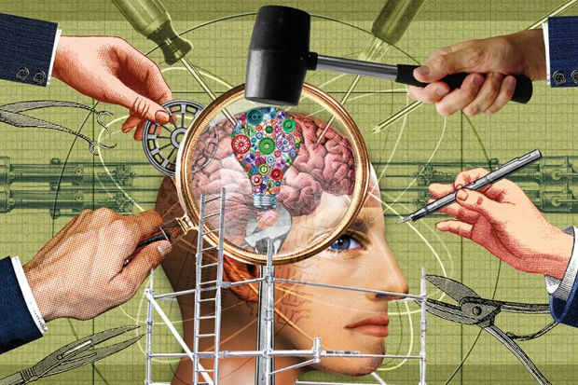
Source: Miles Cole
In today’s tertiary environment, students with a creative inclination can still exercise their imagination. But the chances are that they will not do well if they try.
Internationally, education discourages imaginative growth. Institutions all say that they want creativity to be cultivated and it is often mentioned as a graduate attribute. But the grid of expectations around individual courses makes engaging the imagination uncompetitive for all but an exceptionally talented elite.
Thanks to a well-intentioned educational philosophy, persuasively formulated by John Biggs, teachers try to tell students what the “learning outcomes” (or “intended learning outcomes”) of the course will be. The delivery and learning activities must be in strict alignment with these, as must the assessment. This is known by the term that Biggs coined: constructive alignment.
Surprises are almost seen as a scandal; any academic who publishes learning outcomes in one voice, but then introduces material in another, could be seen as inconsistent, misleading, confusing and downright derelict.
There are many reasons to applaud this rigorous teaching culture. It seems ideal to tell students what to expect and then to come good on the promise. It therefore appears irresponsible not to provide consistent templates, frameworks and scaffolding – the more rigid the better. As far as possible, we specify every detail of how students will be evaluated. Their learning from the outset belongs to the discourse of assessment: it is circumscribed by statements of what constitutes quality through marking rubrics. So students are anxiously plied with all the necessary resources in the same breath as they are confronted with the criteria against which their work will be judged.
Those who insist on following their creative inclinations are less likely to observe the straitjacket of these provisions. Compared with any unimaginative but diligent effort, the flamboyant or daring interpretation will be considered immature or messy, incoherent or eccentric. Rhetorical colour, personal experience, opinion, conjecture and extrapolation are a liability. They are nowhere on the marking rubric, which is instead concerned with evidence, consistency of argument and economy of expression.
Perhaps provisionally, creative responses could be accommodated in the rubric. But the problem is that the learning outcomes that the assessment criteria are supposed to reflect are unlikely to include creativity because while creativity can be encouraged, it cannot easily be taught – even in art or musical composition. Nor is it defensibly measurable and justifiable without arbitrariness. These are the criteria deemed essential to preserve the integrity of the learning outcomes.
Even if, by some sleight of constructive alignment, liberal educators could wangle creativity into the learning outcomes, our increasing tendency to micromanage the process of learning, via learning management systems, is inhospitable to imagination. In the name of engagement, we compel our students to come to heel in the digital environment, mostly with mechanical puzzles that draw them further away from imaginative autonomy.
Over the years, I have been as culpable for this surveillance as the next educator. But after watching the decline of student independence, I have begun to regret my attachment to learning outcomes and constructive alignment. I have concluded that while these are good for the mechanical absorption of facts and workaday competencies, we have to park this shibboleth and develop a different approach to courses that have any aspirations to creativity.
For the short term, I propose that institutions revert to statements of teaching objectives rather than learning outcomes. The former express what teachers hope to achieve in guiding their students through an area of syllabus. We rejected these aspirational statements because they seemed to centre on the teacher rather than the student.
Paradoxically, however, teaching objectives invited more creative freedom. The teacher described the path that the programme would take, but then students would go on their own journey and tell the lecturer, via learning activities and assessment, where their route took them. The teacher’s and the students’ journeys are not the same, and I plead with universities not to treat them as if they were.
Imagination is more than an impulse to invent, compose or paint. It is the mind’s technique for thinking afresh and is therefore central to learning itself, which entails encountering new material and making it your own. Unfamiliar ideas are either rejected as impossibly alien or are seen in the mind’s eye of the learner to tessellate with other ideas or knowledge that they already possess, encouraging them to engage with it.
Towards this marvellous dynamic of tentative thought ownership, I like to engage an appropriately subjective vocabulary. I favour acknowledging hidden factors in the educational environment, such as the niceness of the teacher, the flux between general perspectives and specific detail and, above all, a sense of narrative.
To realise their imaginative potential, students need comfort in the subjectively risky; and in order to encourage them, we have to learn a new sympathetic language that licenses their creativity and our own.
Robert Nelson is associate director for student learning experience at the Monash Education Academy, Monash University. His latest book, Creativity Crisis: Toward a Post-Constructivist Educational Future is published by Monash University Publishing.

